

|  |
| --- |
| Introduction to Database |
| Lecture Note |
| **American International University-Bangladesh** |

# Lecture -11, 12(Sub-query)

#### Objective:

* + Describe the types of problems that subqueries can solve
  + Define subqueries
  + List the types of subqueries
  + Write single-row and multiple-row subqueries

In this lesson, you will learn about more advanced features of the SELECT statement. You can write subqueries in the WHERE clause of another SQL statement to obtain values based on an unknown conditional value. This lesson covers single-row subqueries and multiple-row subqueries.

**Using a Subquery to Solve a Problem**

Suppose you want to write a query to find out who earns a salary greater than Jones’ salary. To solve this problem, you need *two* queries: one query to find what Jones earns and a second query to find who earns more than that amount. You can solve this problem by combining the two queries, placing one query *inside* the other query. The inner query or the *subquery* returns a value that is used by the outer query or the main query. Using a subquery is equivalent to performing two sequential queries and using the result of the first query as the search value in the second query.

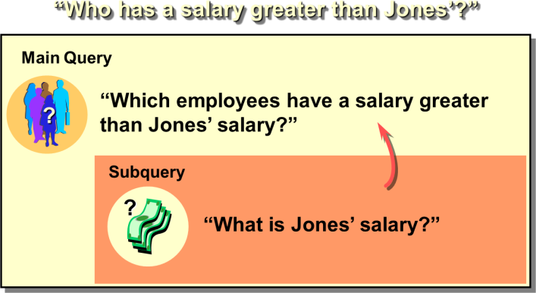

### Subqueries

A subquery is a SELECT statement that is embedded in a clause of another SELECT statement. You can build powerful statements out of simple ones by using subqueries. They can be very useful when you need to select rows from a table with a condition that depends on the data in the table itself.

You can place the subquery in a number of SQL clauses:

* + WHERE clause
  + HAVING clause
  + FROM clause In the syntax:

*operator* includes a comparison operator such as >, =, or IN

**Note:** Comparison operators fall into two classes: single-row operators (>, =, >=, <, <>, <=) and multiple- row operators (IN, ANY, ALL). The subquery is often referred to as a nested SELECT, sub-SELECT, or inner SELECT statement. The subquery generally executes first, and its output is used to complete the query condition for the main or outer query.

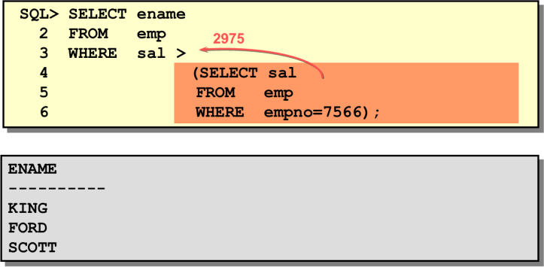

### Guidelines for Using Subqueries

* + A subquery must be enclosed in parentheses.
  + A subquery must appear on the right side of the comparison operator.
  + Subqueries cannot contain an ORDER BY clause. You can have only one ORDER BY clause for a SELECT statement, and if specified it must be the last clause in the main SELECT statement.
  + Two classes of comparison operators are used in subqueries: single-row operators and multiple-row operators.

### Types of Subqueries

* + Single-row subqueries: Queries that return only one row from the inner SELECT statement
  + Multiple-row subqueries: Queries that return more than one row from the inner SELECT statement
  + Multiple-column subqueries: Queries that return more than one column from the inner SELECT statement

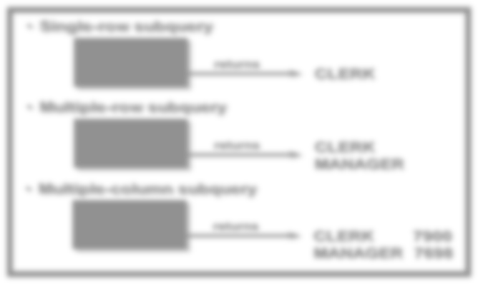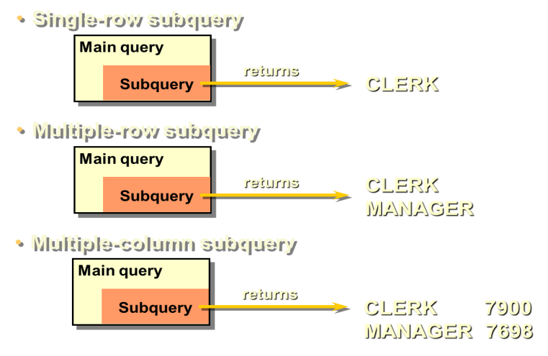

### Single-Row Subqueries

A *single-row subquery* is one that returns one row from the inner SELECT statement. This type of subquery uses a single-row operator.

### Example

Display the employees whose job title is the same as that of employee 7369.

### Executing Single-Row Subqueries

A SELECT statement can be considered as a query block. The example on the displays employees whose job title is the same as that of employee 7369 and whose salary is greater than that of employee 7876.

The example consists of three query blocks: the outer query and two inner queries. The inner query blocks are executed first, producing the query results: CLERK and 1100, respectively. The outer query block is then processed and uses the values returned by the inner queries to complete its search conditions.

Both inner queries return single values (CLERK and 1100, respectively), so this SQL statement is called a single-row subquery.

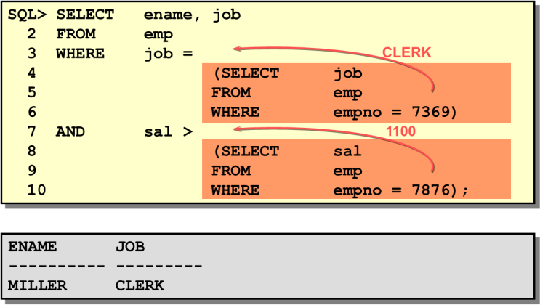

### Using Group Functions in a Subquery

You can display data from a main query by using a group function in a subquery to return a single row. The subquery is in parentheses and is placed after the comparison operator.

The example displays the employee name, job title, and salary of all employees whose salary is equal to the minimum salary. The MIN group function returns a single value (800) to the outer query.

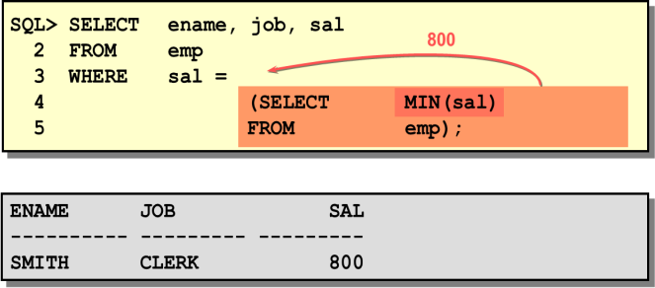

### HAVING Clause with Subqueries

You can use subqueries not only in the WHERE clause, but also in the HAVING clause. The Oracle Server executes the subquery, and the results are returned into the HAVING clause of the main query. The SQL statement stated below displays all the departments that have a minimum salary greater than that of department 20.

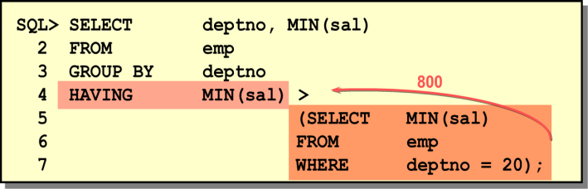

### Errors with Subqueries

One common error with subqueries is more than one row returned for a single-row subquery. In the SQL statement shown below, the subquery contains a GROUP BY (deptno) clause, which implies that the subquery will return multiple rows, one for each group it finds. In this case, the result of the subquery will be 800, 1300, and 950. The outer query takes the results of the subquery (800, 950, 1300) and uses these results in its WHERE clause. The WHERE clause contains an equal (=) operator, a single-row comparison operator expecting only one value. The = operator cannot accept more than one value from the subquery and hence generates the error. To correct this error, change the = operator to IN.

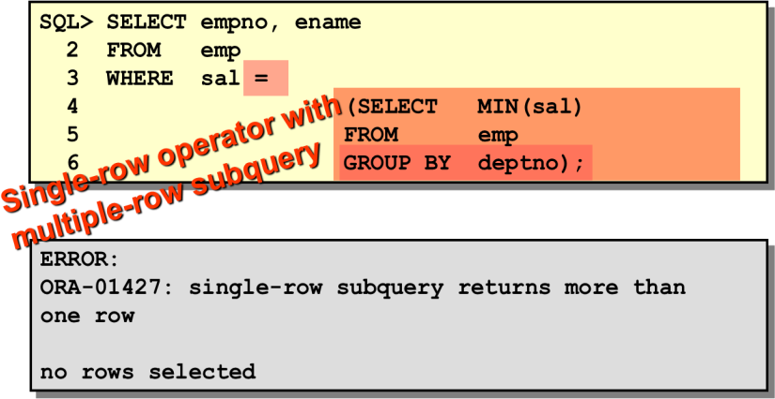

### Problems with Subqueries

A common problem with subqueries is no rows being returned by the inner query. In the SQL statement given below, the subquery contains a WHERE (ename='SMYTHE') clause. Presumably, the intention is to find the employee whose name is Smythe. The statement seems to be correct but selects no rows when executed.

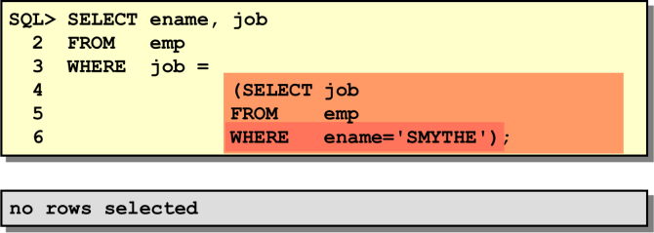

The problem is that Smythe is misspelled. There is no employee named Smythe. So the subquery returns no rows. The outer query takes the results of the subquery (null) and uses these results in its WHERE clause. The outer query finds no employee with a job title equal to null and so returns no rows.

### Multiple-Row Subqueries

Subqueries that return more than one row are called *multiple-row subqueries*. You use a multiple-row operator, instead of a single-row operator, with a multiple-row subquery. The multiple-row operator expects one or more values.

The ANY operator (and its synonym SOME operator) compares a value to *each* value returned by a subquery. The example displays employees whose salary is less than any clerk and who are not clerks. The maximum salary that a clerk earns is $1300. The SQL statement displays all the employees who are not clerks but earn less than $1300. <ANY means less than the maximum. >ANY means more than the minimum. =ANY is equivalent to IN.

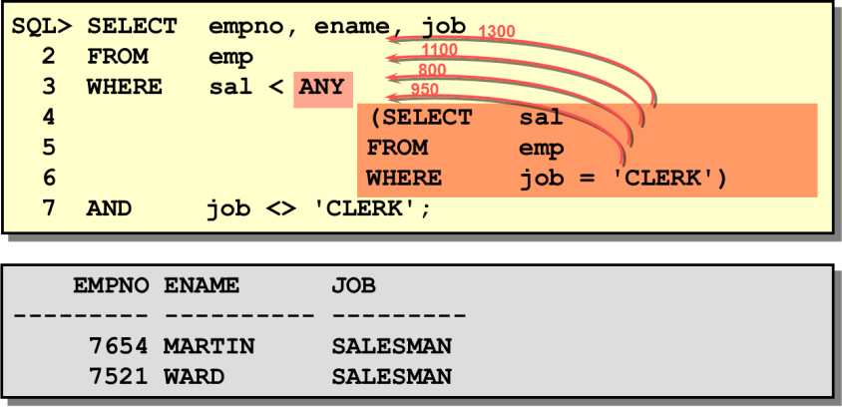

The ALL operator compares a value to *every* value returned by a subquery. The example displays employees whose salary is greater than the average salaries of all the departments. The highest average salary of a department is $2916.66, so the query returns those employees whose salary is greater than

$2916.66. >ALL means more than the maximum and <ALL means less than the minimum. The NOT operator can be used with IN, ANY, and ALL operators.

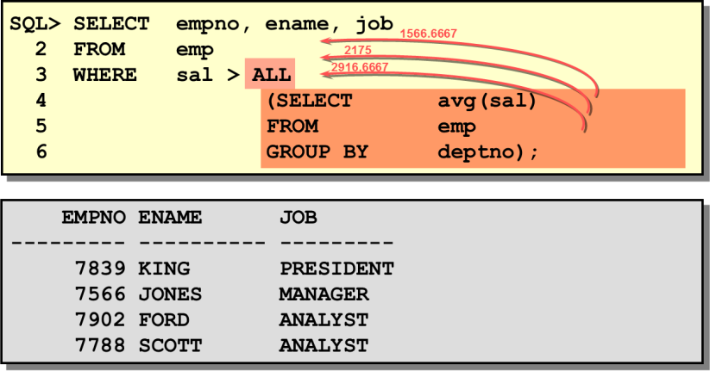

### Multiple-Column Subqueries

So far you have written single-row subqueries and multiple-row subqueries where only one column was compared in the WHERE clause or HAVING clause of the SELECT statement. If you want to compare two or more columns, you must write a compound WHERE clause using logical operators. Multiple-column subqueries enable you to combine duplicate WHERE conditions into a single WHERE clause.

The example below shows a multiple-column subquery because the subquery returns more than one column. It compares the values in the PRODID column and the QTY column of each candidate row in the ITEM table to the values in the PRODID column and QTY column for items in order 605. First, execute the subquery to see the PRODID and QTY values for each item in order 605.

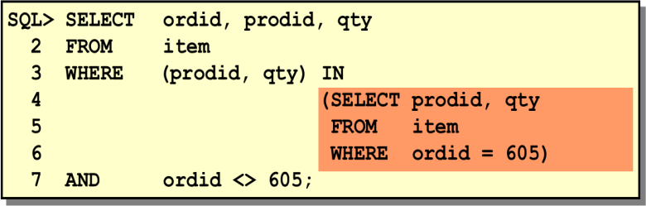

When the above SQL statement is executed, the Oracle server compares the values in both the PRODID and QTY columns and returns those orders where the product number and quantity for *that* product match *both* the product number and quantity for an item in order 605.

The output of the SQL statement is:

|  |  |  |
| --- | --- | --- |
| **ORDID** | **PRODID** | **QTY** |
| 617 | 100861 | 100 |
| 617 | 100870 | 500 |
| 616 | 102130 | 10 |

The output shows that there are three items in other orders that contain the same product number and quantity as an item in order 605. For example, order 617 has ordered a quantity 500 of product 100870. Order 605 has also ordered a quantity 500 of product 100870. Therefore, that candidate row is part of the output.

### Pairwise Versus Nonpairwise Comparisons

Column comparisons in a multiple-column subquery can be pairwise comparisons or nonpairwise comparisons. The example shows the product numbers and quantities of the items in order 605. In the example, a pairwise comparison was executed in the WHERE clause. Each candidate row in the SELECT statement must have *both* the same product number and same quantity as an item in order 605. This is illustrated on the left side of the example stated above. The arrows indicate that both the product number and quantity in a candidate row match a product number and quantity of an item in order 605.

A multiple-column subquery can also be a nonpairwise comparison. If you want a nonpairwise comparison (a cross product), you must use a WHERE clause with multiple conditions. A candidate row

must match the multiple conditions in the WHERE clause but the values are compared individually. A candidate row must match some product number in order 605 as well as some quantity in order 605, but these values do not need to be in the same row. This is illustrated on the right side of the example. For example, product 102130 appears in other orders, one order matching the quantity in order 605 (10), and another order having a quantity of 500. The arrows show a sampling of the various quantities ordered for a particular product.

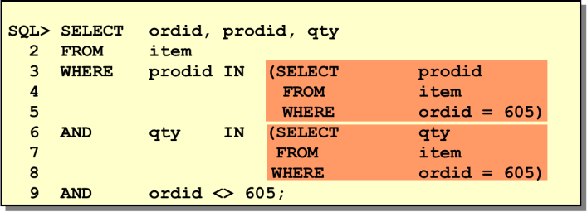

***Exercise:***

1. Display all the employees who are earning more than all the managers.
2. Display all the employees who are earning more than any of the managers.
3. Select employee number, job & salaries of all the Analysts who are earning more than any of the managers.
4. Select all the employees who work in DALLAS.
5. Select department name & location of all the employees working for CLARK.
6. Select all the departmental information for all the managers
7. Display the first maximum salary.
8. Display the second maximum salary.
9. Display the third maximum salary.
10. Display all the managers & clerks who work in Accounts and Marketing departments.
11. Display all the salesmen who are not located at DALLAS.
12. Get all the employees who work in the same departments as of SCOTT.
13. Select all the employees who are earning same as SMITH.
14. Display all the employees who are getting some commission in marketing department where the employees have joined only on weekdays.
15. Display all the employees who are getting more than the average salaries of all the employees.

# Lecture 14, 16 (Normalization)

# *Objective:*

# Introductions

# The Normal Forms

# Primary Key

# Relationships and Referential Integrity

# When NOT to Normalize

# Real World Exercise

# *Normalization Definition:*

# In relational database design, the process of organizing data to minimize duplication.

# *Normalization* usually involves dividing a database into two or more tables and defining relationships between the tables.

# The objective is to isolate data so that additions, deletions, and modifications of a field can be made in just one table and then propagated through the rest of the database via the defined relationships.”

# "Normalization" refers to the process of creating an efficient, reliable, flexible, and appropriate "relational" structure for storing information. Normalized data must be in a "relational" data structure.

***Anomaly***

An error or inconsistency that may result when a user attempts to update a table that contains redundant data.

There are three types of Anomaly - **Insertion Anomaly, Deletion Anomaly, Modification Anomaly**

***Well Structure Relation***

A relation that contains minimal redundancy and allows users to insert, modify and delete the rows without error or inconsistencies.

# FIG5-2B

Question – Is this a relation?

Answer – Yes: unique rows and no multivalued attributes

Question – What’s the primary key?

Answer – Composite: Emp_ID, Course_Title

# *Anomalies in the above table:*

* **Insertion** – can’t enter a new employee without having the employee take a class
* **Deletion** – if we remove employee 140, we lose information about the existence of a Tax Acc class
* **Modification** – giving a salary increase to employee 100 forces us to update multiple records

# *The Normal Forms:*

A series of logical steps to take to normalize data tables

* First Normal Form (1NF)
* Second Normal Form (2NF)
* Third Normal Form (3NF)

***First Normal Form Rule:***

A relation that contains no multivalued Attributes.

All columns (fields) must be atomic. Means no repeating items in columns



* ***Before 1NF applied***

|  |  |  |  |  |  |
| --- | --- | --- | --- | --- | --- |
| **Employees** | | | | | |
| **emp_id** | **name** | **dept_name** | **salary** | **course_title** | **date_completed** |
| 100 | M.S. | MKT | 48000 | SPSS  Survey | 8/9/16  10/7/16 |
| 140 | A.B. | ACC | 52000 | Tally ACC | 12/8/16 |
| 110 | C.L. | I.S. | 43000 | SPSS  CTT | 1/12/16  4/12/16 |

* ***After 1NF***

|  |  |  |  |  |  |
| --- | --- | --- | --- | --- | --- |
| **Employees** | | | | | |
| **emp_id** | **name** | **dept_name** | **salary** | **course_title** | **date_completed** |
| 100 | M.S. | MKT | 48000 | SPSS | 8/9/16 |
| 100 | M.S. | MKT | 48000 | Survey | 10/7/16 |
| 140 | A.B. | ACC | 52000 | Tally ACC | 12/8/16 |
| 110 | C.L. | I.S. | 43000 | SPSS | 1/12/16 |
| 110 | C.L. | I.S. | 43000 | CTT | 4/12/16 |

***Second Normal Form Rule:***

A relation in First Normal Form in which every attribute in fully functionally dependent in the primary key or Partial Functional dependency should be removed.

***Partial Functional Dependency***

A functional dependency in which one or more non-key attribute are functionally dependent in part (but not all) of the primary key.

***Functional Dependency***

A constrain between two attribute or two sets of attributes.

**EmpID, CourseTitle 🡺 DateCompleted**

**EmpID 🡺 Name, DeptName, Salary**

So, the above table not in 2NF.

* ***After 2NF***

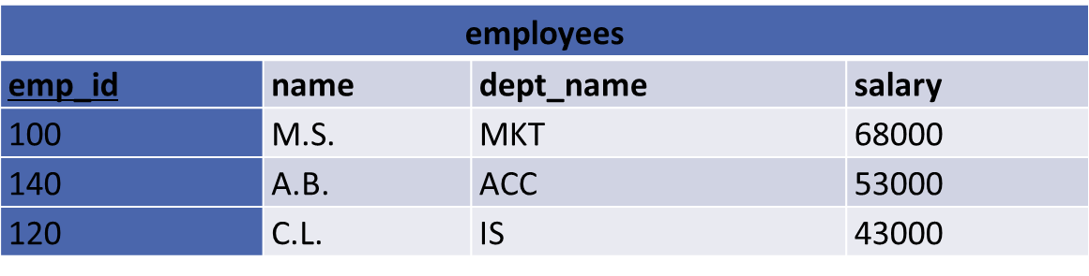

# 

***Third Normal Form Rule:***

A relation in Second Normal Form has no Transitive Dependency present.

***Transitive Dependency:*** ***A Functional Dependency between two (or more) non-key attributes.***

***-Before 3NF applied***

|  |  |  |  |
| --- | --- | --- | --- |
| **Sales** | | | |
| **cust_id** | **Name** | **sales_person** | **region** |
| 8023 | Anderson | Smith | South |
| 9167 | Boston | Hikes | West |
| 7924 | Haile | Smith | South |
| 6837 | Tuck | David | East |
| 8596 | Haile | Hikes | West |
| 7018 | Anderson | Forth | North |

**CustID 🡪 Name**

**CustID 🡪 Salesperson**

**CustID 🡪 Region**

**All this is OK**

**(2nd NF)**

**BUT**

**CustID 🡪 Salesperson 🡪 Region**

***Transitive dependency***

***(not 3rd NF)***

* ***After 3NF***

# 

# Example with ER Diagram

# 

**Teaching:**

**UNF: 1st: Sid,Sname,City,Country,Tid,Tname,Skill**

**1NF:1st: Sid, Skill , Tid , Sname,City,Country, Tname**

**2NF:1st: Skill , Tid**

**2nd : Sid, Sname,City,Country**

**3rd: Tid, Tname**

**4th: Tid, Sid**

**3NF: 1st: Skill , Tid**

**2nd : Sid, Sname ,tid,city**

**3rd: City,Country**

**4th : Tid, Tname**

**5th: Tid, Sid**

**Belongs to:**

**UNF: 1st: Sid,Sname,City,Country,Did, Dname,Phone**

**1NF: 1st: Sid, Did ,Phone ,Sname,City,Country, Dname**

**2NF: 1st: Sid , Sname,City,Country,Did**

**2nd: Did ,Phone , Dname**

**3NF: 1st: Sid , Sname, City,Did**

**2nd: City,Country**

**3rd : Did ,Phone , Dname**

**Final Table:**

**1st: Skill , Tid**

**2nd : Sid, Sname,city**

**3rd: City,Country**

**4th : Tid, Tname**

**5th: Tid, Sid**

**6th : Sid , Sname, City,Did**

**7th : Did ,Phone , Dname**

# Lecture-13, 15(Joining: Displaying Data from Multiple Tables)

#### Objective:

* Write SELECT statements to access data from more than one table using equality and nonequality joins.
* View data that generally does not meet a join condition by using outer joins.
* Join a table to itself.

#### Data from Multiple Tables

Sometimes you need to use data from more than one table. In the example stated below, the report displays data from two separate tables.

* EMPNO exists in the EMP table.
* DEPTNO exists in both the EMP and DEPT the tables.
* LOC exists in the DEPT table.

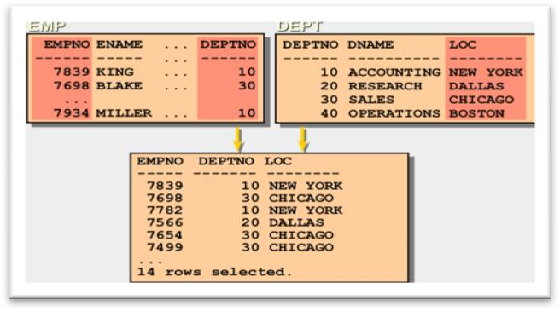

To produce the report, you need to link EMP and DEPT tables and access data from both of them.

**Defining Joins**

When data from more than one table in the database is required, a *join* condition is used. Rows in one table can be joined to rows in another table according to common values existing in corresponding columns, that is, usually primary and foreign key columns. To display data from two or more related tables, write a simple join condition in the WHERE clause.

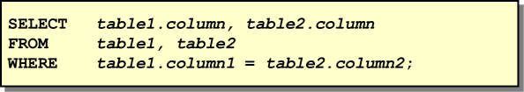

In the syntax:

*table1.column* denotes the table and column from which data is retrieved

*table1.column1* = is the condition that joins (or relates) the tables together *table2.column2*

### Guidelines

* When writing a SELECT statement that joins tables, precede the column name with the table name for clarity and to enhance database access.
* If the same column name appears in more than one table, the column name must be prefixed with the table name.
* To join *n* tables together, you need a minimum of (*n-1*) join conditions. Therefore, to join four tables, a minimum of three joins are required. This rule may not apply if your table has a concatenated primary key, in which case more than one column is required to uniquely identify each row.

### Cartesian Product

When a join condition is invalid or omitted completely, the result is a *Cartesian product* in which all combinations of rows will be displayed. All rows in the first table are joined to all rows in the second table. A Cartesian product tends to generate a large number of rows, and its result is rarely useful. You should always include a valid join condition in a WHERE clause, unless you have a specific need to combine all rows from all tables. A Cartesian product is generated if a join condition is omitted. The example displays employee name and department name from EMP and DEPT tables. Because no WHERE clause has been specified, all rows (14 rows) from the EMP table are joined with all rows (4 rows) in the DEPT table, thereby generating 56 rows in the output.

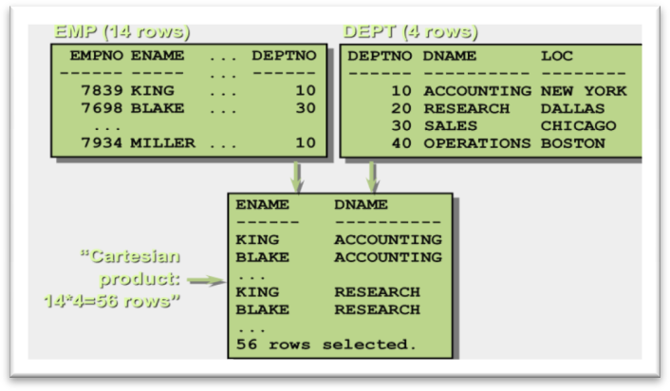

### Types of Joins

There are two main types of join conditions:

* Equijoins
* Non-equijoins

Additional join methods include the following:

* Outer joins
* Self joins

### Equijoins

To determine the name of an employee’s department, you compare the value in the DEPTNO column in the EMP table with the DEPTNO values in the DEPT table. The relationship between the EMP and DEPT tables is an *equijoin*—that is, values in the DEPTNO column on both tables must be equal. Frequently, this type of join involves primary and foreign key complements. Equijoins are also called *simple joins* or *inner joins*.

### Retrieving Records with Equijoins

In the below example:

* The SELECT clause specifies the column names to retrieve:
  + employee name, employee number, and department number, which are columns in the EMP table
  + department number, department name, and location, which are columns in the DEPT table
* The FROM clause specifies the two tables that the database must access:
  + EMP table
  + DEPT table
* The WHERE clause specifies how the tables are to be joined: EMP.DEPTNO=DEPT.DEPTNO

Because the DEPTNO column is common to both tables, it must be prefixed by the table name to avoid ambiguity.

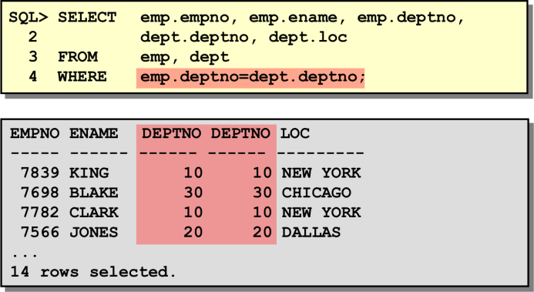

### Qualifying Ambiguous Column Names

You need to qualify the names of the columns in the WHERE clause with the table name to avoid ambiguity. Without the table prefixes, the DEPTNO column could be from either the DEPT table or the EMP table. It is necessary to add the table prefix to execute your query. If there are no common column names between the two tables, there is no need to qualify the columns. However, you will gain improved performance by using the table prefix because you tell the Oracle Server exactly where to go to find columns. The requirement to qualify ambiguous column names is also applicable to columns that may be ambiguous in other clauses, such as the SELECT clause or the ORDER BY clause.

### Table Aliases

Qualifying column names with table names can be very time consuming, particularly if table names are lengthy. You can use table *aliases* instead of table names. Just as a column alias gives a column another name, a table alias gives a table another name. Table aliases help to keep SQL code smaller, therefore using less memory. Notice how table aliases are identified in the FROM clause in the example. The table name is specified in full, followed by a space and then the table alias. The EMP table has been given an alias of E, whereas the DEPT table has an alias of D.

### Guidelines

* Table aliases can be up to 30 characters in length, but the shorter they are the better.
* If a table alias is used for a particular table name in the FROM clause, then that table alias must be substituted for the table name throughout the SELECT statement.
* Table aliases should be meaningful.
* The table alias is valid only for the current SELECT statement.

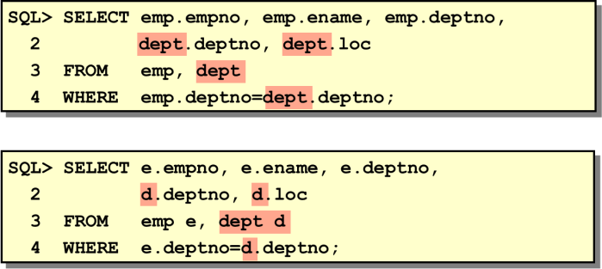

### Non-Equijoins

The relationship between the EMP table and the SALGRADE table is a non-equijoin, meaning that no column in the EMP table corresponds directly to a column in the SALGRADE table. The relationship between the two tables is that the SAL column in the EMP table is between the LOSAL and HISAL column of the SALGRADE table. The relationship is obtained using an operator other than equal (=).The below example creates a non-equijoin to evaluate an employee’s salary grade. The salary must be *between* any pair of the low and high salary ranges. It is important to note that all employees appear exactly once when this query is executed. No employee is repeated in the list. There are two reasons for this:

* None of the rows in the salary grade table contain grades that overlap. That is, the salary value for an employee can only lie between the low salary and high salary values of one of the rows in the salary grade table.
* All of the employees’ salaries lie within the limits provided by the salary grade table. That is, no employee earns less than the lowest value contained in the LOSAL column or more than the highest value contained in the HISAL column.

•

**Note:** Other operators such as <= and >= could be used, but BETWEEN is the simplest. Remember to specify the low value first and the high value last when using BETWEEN. Table aliases have been specified for performance reasons, not because of possible ambiguity.

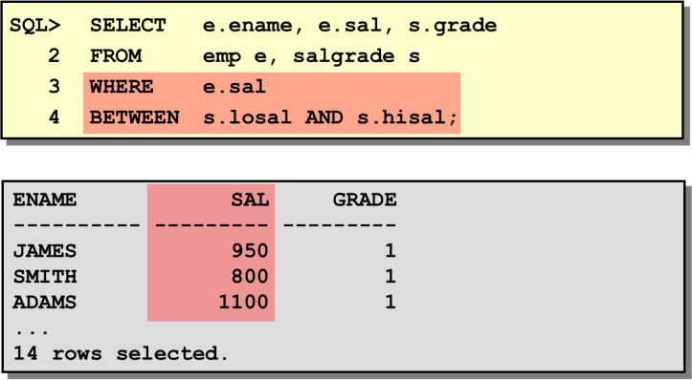

### Returning Records with No Direct Match with Outer Joins

If a row does not satisfy a join condition, the row will not appear in the query result. For example, in the equijoin condition of EMP and DEPT tables, department OPERATIONS does not appear because no one works in that department. The missing row(s) can be returned if an *outer join* operator is used in the join condition. The operator is a plus sign enclosed in parentheses (+), and it is *placed on the* “*side*” *of the join that is deficient in information*. This operator has the effect of creating one or more null rows, to which one or more rows from the no deficient table can be joined.

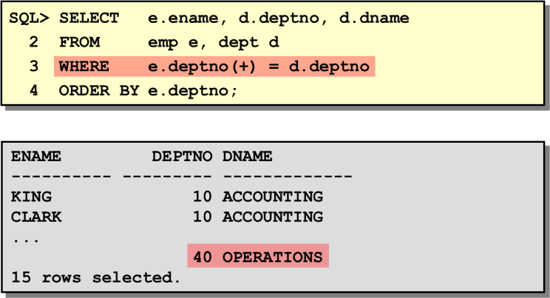

In the syntax:

***table1.column =*** is the condition that joins (or relates) the tables together.

***table2.column* (+)** is the outer join symbol, which can be placed on either side of the WHERE clause condition, but not on both sides (Place the outer join symbol following the name of the column in the table without the matching rows.)

### Joining a Table to Itself

Sometimes you need to join a table to itself. To find the name of each employee’s manager, you need to join the EMP table to itself, or perform a self-join. For example, to find the name of Blake’s manager, you need to:

* Find Blake in the EMP table by looking at the ENAME column.
* Find the manager number for Blake by looking at the MGR column. Blake’s manager number is 7839.
* Find the name of the manager with EMPNO 7839 by looking at the ENAME column. King’s employee number is 7839, so King is Blake’s manager.

In this process, you look in the table twice. The first time you look in the table to find Blake in the ENAME column and MGR value of 7839. The second time you look in the EMPNO column to find 7839 and the ENAME column to find King.

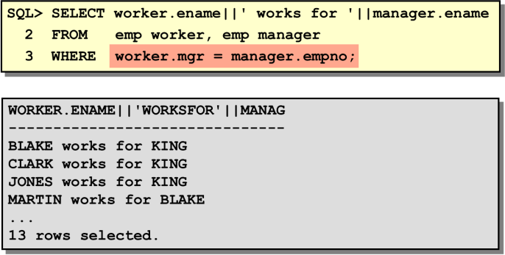

The example stated above joins the EMP table to itself. To simulate two tables in the FROM clause, there are two aliases, namely WORKER and MANAGER, for the same table, EMP. In this example the WHERE clause contains the join condition that means “where a worker’s manager number matches the employee number for the manager.”

***Exercise:***

**ASSIGNMENTS ON EQUI-JOINS**

* 1. Display all the managers & clerks who work in Accounts and Marketing departments. 2.Display all the salesmen who are not located at DALLAS.

3.Select department name & location of all the employees working for CLARK. 4.Select all the departmental information for all the managers

1. Select all the employees who work in DALLAS.
2. Delete the records from the DEPT table that don’t have matching records in EMP

**ASSIGNMENTS ON OUTER-JOINS**

1. Display all the departmental information for all the existing employees and if a department has no employees display it as “No employees”.
2. Get all the matching & non-matching records from both the tables.
3. Get only the non-matching records from DEPT table (matching records shouldn’t be selected).
4. Select all the employees name along with their manager names, and if an employee does not have a manager, display him as “CEO”.

**ASSIGNMENTS ON SELF-JOINS**

1. Get all the employees who work in the same departments as of SCOTT
2. Display all the employees who have joined before their managers.
3. List all the employees who are earning more than their managers.
4. Fetch all the employees who are earning same salaries.
5. Select all the employees who are earning same as SMITH.Display employee name , his date of joining, his manager name & his manager's date of joining.

# Lecture-17 (View)

#### View:

You can present logical subsets or combinations of data by creating views of tables. A view is a logical table based on a table or another view. A view contains no data of its own but is like a window through which data from tables can be viewed or changed. The tables on which view is based are called *base tables*. The view is stored as a SELECT statement in the data dictionary.

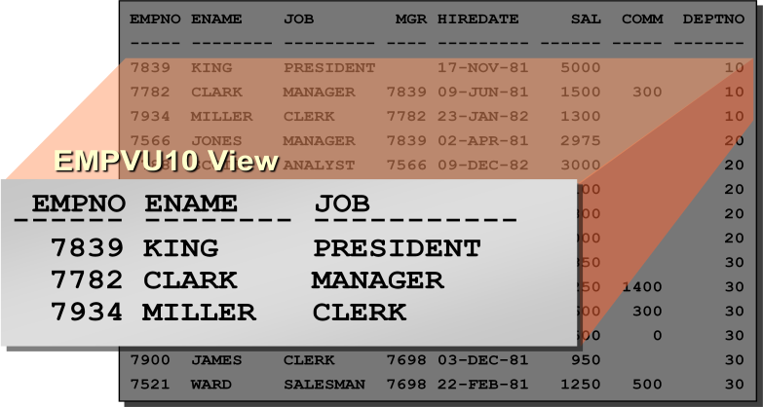

**Simple Syntax:**

CREATE VIEW <view_name> AS

SELECT <col>,<col> FROM <table_name> WHERE <condition> ;

**Complex Syntax:**

CREATE [OR REPLACE] [FORCE|NOFORCE] VIEW <view> [(alias[, alias]...)]

AS <subquery>

[WITH CHECK OPTION [CONSTRAINT constraint]] [WITH READ ONLY];

In the syntax:

|  |  |
| --- | --- |
| **OR REPLACE** | re-creates the view if it already exists |
| **FORCE** | creates the view regardless of whether or not the base tables exist |
| **NOFORCE** | creates the view only if the base tables exist (This is the default.) |
| **View** | is the name of the view |
| **Alias** | specifies names for the expressions selected by the view’s query (The number of aliases must match the number of expressions selected by the  view.) |
| **subquery** | is a complete SELECT statement (You can use aliases for the columns in the  SELECT list.) |
| **WITH CHECK**  **OPTION** | specifies that only rows accessible to the view can be inserted or updated |

|  |  |
| --- | --- |
| **constraint** | is the name assigned to the CHECK OPTION constraint |
| **WITH READ ONLY** | ensures that no DML operations can be performed on this view |

### Retrieving Data from a View

You can retrieve data from a view as you would from any table. You can either display the contents of the entire view or just view specific rows and columns.

Syntax: *SELECT * FROM <view_name>;*

### Modifying a View

The OR REPLACE option allows a view to be created even if one exists with this name already, thus replacing the old version of the view for its owner. This means that the view can be altered without dropping, re-creating, and regranting object privileges.

Note: When assigning column aliases in the CREATE VIEW clause, remember that the aliases are listed in the same order as the columns in the subquery.

### Performing DML Operations on a View

You can perform DML operations on data through a view if those operations follow certain rules.

* You can remove a row from a view unless it contains any of the following:
* Group functions
* A GROUP BY clause
* The DISTINCT keyword

You can modify data in a view unless it contains any of the conditions mentioned in the previous section and any of the following:

* Columns defined by expressions—for example, SALARY * 12
* The ROWNUM pseudocolumn

You can add data through a view unless it contains any of the above and there are NOT NULL columns, without a default value, in the base table that are not selected by the view. All required values must be present in the view. Remember that you are adding values directly into the underlying table through the view.

### Removing a View

You use the DROP VIEW statement to remove a view. The statement removes the view definition from the database. Dropping views has no effect on the tables on which the view was based. Views or other applications based on deleted views become invalid. Only the creator or a user with the DROP ANY VIEW privilege can remove a view.

**Syntax:** *DROP VIEW <view_name>;*

### Inline Views

* An inline view is a sub query with an alias (correlation name) that you can use within a SQL statement.
* An inline view is similar to using a named sub query in the FROM clause of the main query.
* An inline view is not a schema object.

### Exercise

1. Create a view called **EMP_VU** based on the employee number, employee name, and department number from the EMP table. Change the heading for the employee name to EMPLOYEE.
2. Display the contents of the **EMP_VU** view. EMPNO EMPLOYEE DEPTNO

|  |  |  |  |
| --- | --- | --- | --- |
| 7839 | KING |  | 10 |
| 7698 | BLAKE |  | 30 |
| 7782 | CLARK |  | 10 |
| 7566 | JONES |  | 20 |
| 7654 | MARTIN |  | 30 |
| 7499 | ALLEN |  | 30 |
| 7844 | TURNER |  | 30 |
| 7900 | JAMES |  | 30 |
| 7521 | WARD |  | 30 |
| 7902 | FORD |  | 20 |
| 7369 | SMITH |  | 20 |
| 7788 | SCOTT |  | 20 |
| 7876 | ADAMS | 20 |  |
| 7934 | MILLER |  | 10 |

1. using your view EMP_VU, enter a query to display all employee names and department numbers.

|  |  |
| --- | --- |
| EMPLOYEE | DEPTNO |
| KING | 10 |
| BLAKE | 30 |
| CLARK | 10 |

JONES 20

MARTIN 30

1. Create a view named **DEPT20** that contains the employee number, employee name, and department number for all employees in department 20. Label the view column EMPLOYEE_ID, EMPLOYEE, and DEPARTMENT_ID. Do not allow an employee to be reassigned to another department through the view.
2. Create a view called SALARY_VU based on the employee name, department name, salary, and salary grade for all employees. Label the columns Employee, Department, Salary, and Grade, respectively.

** Please save the SQL commands in a text file for further use.

**Lecture-18, 20 (Relational Algebra)**

**Objectives:**

Basic operators

Join

Notations

Example

**Relational Algebra:**

Relational algebra is a procedural query language. It gives a step by step process to obtain the result of the query. It uses operators to perform queries.

* **Six basic operators**
  + select: σ
  + project: ∏
  + union: ∪
  + set difference: *–*
  + Cartesian product: x
  + rename: *ρ*
* The operators take one or two relations as inputs and produce a new relation as a result.

**Banking Example**

*branch (branch_name, branch_city, assets)*

*customer (customer_name, customer_street, customer_city)*

*account (account_number, branch_name, balance)*

*loan (loan_number, branch_name, amount)*

*depositor (customer_name, account_number)*

*borrower**(customer_name, loan_number)*

**Select Operation:**

* Notation: *σ* *p*(*r*)
* *p* is called the **selection predicate**
* Defined as:  
    
   *σp*(***r***) = {*t* | *t* ∈ *r* **and** *p(t)*}

Where *p* is a formula in propositional calculus consisting of **terms** connected by : ∧ (**and**), ∨ (**or**), ¬ (**not**)  
Each **term** is one of:

<attribute> *op* <attribute> or <constant>

where *op* is one of: =, ≠, >, ≥. <. ≤

* Example of selection:  
    
   σ *branch_name=“Perryridge”*(*account*)

**Select Operation Example:**

*D*

Relation r

*A*

*B*

*C*

*α*

*α*

*β*

*β*

*α*

*β*

*β*

*β*

*1*

*5*

*12*

*23*

*7*

*7*

*3*

*10*

σA=B ^ D > 5 (r)

*A*

*B*

*C*

*α*

*β*

*α*

*β*

*1*

*23*

*7*

*10*

*D*

**Project Operation:**

* **Notation:** 
  + **where *A1, A2* are attribute names and *r* is a relation name.**
* **The result is defined as the relation of *k* columns obtained by erasing the columns that are not listed**
* **Duplicate rows removed from result, since relations are sets**
* **Example: To eliminate the *branch_name* attribute of *account*  
    
   ∏*account_number, balance* (*account*)**

**Project Operation Example:**

Relation *r*:

*A*

*B*

*C*

*α*

*α*

*β*

*β*

*10*

*20*

*30*

*40*

*1*

*1*

*1*

*2*

*A*

*C*

*α*

*α*

*β*

*β*

*1*

*1*

*1*

*2*

=

*A*

*C*

*α*

*β*

*β*

*1*

*1*

*2*

**What is Sequence**

∏A,C (*r*)

### 

### Composition of Relational Operations

### Find the customer who live in Harrison

### ∏*customer_name* (σ *customer_city=”Harrison”* (*customer*))

### Notice that instead of giving the name of a relation as the argument of the projection operation, we give an expression that evaluates to a relation

### Union Operation:

### Notation: *r* ∪ *s*

### Defined as:

### *r* ∪ *s* = {*t* | *t* ∈ *r* or *t* ∈ *s*}

### For *r* ∪ *s* to be valid.

### *r,* *s* must have the *same* arity (same number of attributes)

### 2. The attribute domains must be compatible (example: 2nd column of *r* deals with the same type of values as does the 2nd column of *s*)

### Example: to find all customers with either an account or a loan ∏*customer_name* (*depositor*) ∪ ∏*customer_name* (*borrower)*

### Union Operation Example:

Relations *r, s:*

*A*

*B*

*α*

*α*

*β*

*1*

*2*

*1*

*A*

*B*

*α*

*β*

*2*

*3*

*r*

*s*

*A*

*B*

*α*

*α*

*β*

*β*

*1*

*2*

*1*

*3*

**σ**(r ∪s):

### Set Difference Operation:

### Notation *r – s*

### Defined as:

### *r – s* = {*t* | *t* ∈ *r* and t ∉ *s*}

### Set differences must be taken between compatible relations.

### *r* and *s* must have the same arity

### attribute domains of *r* and *s* must be compatible

### Set Difference Operation Example:

Relations *r*, *s*:

σ (*r – s):*

*A*

*B*

*α*

*α*

*β*

*1*

*2*

*1*

*A*

*B*

*α*

*β*

*2*

*3*

*r*

*s*

*A*

*B*

*α*

*β*

*1*

*1*

### Cartesian-Product Operation:

### Notation *r* x *s*

### Defined as:

### *r* x *s* = {*t q* | *t* ∈ *r* and *q* ∈ *s*}

### Assume that attributes of r(R) and s(S) are disjoint. (That is, *R* ∩ *S* = *∅*).

### If attributes of *r(R)* and *s(S*) are not disjoint, then renaming must be used.

### Cartesian Product Operation Example:

Relations *r, s*:

σ (*r* x *s)*:

*A*

*B*

*α*

*β*

*1*

*2*

*A*

*B*

*α*

*α*

*α*

*α*

*β*

*β*

*β*

*β*

*1*

*1*

*1*

*1*

*2*

*2*

*2*

*2*

*C*

*D*

*α*

*β*

*β*

*γ*

*α*

*β*

*β*

*γ*

*10*

*10*

*20*

*10*

*10*

*10*

*20*

*10*

*E*

*a*

*a*

*b*

*b*

*a*

*a*

*b*

*b*

*C*

*D*

*α*

*β*

*β*

*γ*

*10*

*10*

*20*

*10*

*E*

*a*

*a*

*b*

*b*

*r*

*s*

### Joining Operations:

### 

*A*

*B*

*α*

*α*

*α*

*α*

*β*

*β*

*β*

*β*

*1*

*1*

*1*

*1*

*2*

*2*

*2*

*2*

*C*

*D*

*E*

*a*

*a*

*b*

*b*

*a*

*a*

*b*

*b*

*α*

*β*

*β*

*1*

*2*

*2*

*α*

*β*

*β*

*10*

*10*

*20*

*a*

*a*

*b*

### σ (*r x s)*

*10*

*10*

*20*

*10*

*10*

*10*

*20*

*10*

*α*

*β*

*β*

*γ   
α*

*β*

*β*

*γ*

*A*

*B*

*C*

*E*

*D*

**σA=C(*r x s*)**

* σA=C(*r x s*)

### Rename Operation:

### Allows us to name, and therefore to refer to, the results of relational-algebra expressions.

### Allows us to refer to a relation by more than one name.

### Example:

### *ρ x* (*E*)

### returns the expression *E* under the name *X*

### If a relational-algebra expression *E* has arity *n*, then



### 

### returns the result of expression *E* under the name *X*, and with the

### attributes renamed to *A1 , A2 , …., An* .

### Example Queries:

### Q. Find the names of all customers who have a loan at the Perryridge branch.

### Ans: ∏customer_name (σbranch_name = “Perryridge” ( σborrower.loan_number = loan.loan_number (borrower x loan)))

### Natural-Join Operation:

Notation: r s

* Let *r* and *s* be relations on schemas *R* and *S* respectively.   
  Then, r s is a relation on schema *R* ∪ *S* obtained as follows:
* Consider each pair of tuples *tr* from *r* and *ts* from *s*.
* If *tr* and *ts* have the same value on each of the attributes in *R* ∩ *S*, add a tuple *t* to the result, where
  + - *t* has the same value as *tr* on *r*
    - *t* has the same value as *ts* on *s*

Example:

*R* = (*A, B, C, D*)

*S* = (*E, B, D*)

* + Result schema = (*A, B, C, D, E*)
  + σ (*r* *s)* is defined as:  
     ∏*r.A, r.B, r.C, r.D, s.E* (σ*r.B = s.B* ∧ *r.D = s.D* (*r*  x *s*))

**Natural Join Operation – Example:**

Relations r, s:

*B*

*α*

*β*

*γ*

*α*

*δ*

*1*

*2*

*4*

*1*

*2*

*C*

*D*

*α*

*γ*

*β*

*γ*

*β*

a

a

b

a

b

*B*

*1*

*3*

*1*

*2*

*3*

*D*

a

a

a

b

b

*E*

*α*

*β*

*γ*

*δ*

*∈*

*r*

*s*

*A*

*A*

*B*

*α*

*α*

*α*

*α*

*δ*

*1*

*1*

*1*

*1*

*2*

*C*

*D*

*α*

*α*

*γ*

*γ*

*β*

a

a

a

a

b

*E*

*α*

*γ*

*α*

*γ*

*δ*

σ (r s)

### Extended Relational-Algebra-Operations:

### Generalized Projection

### Aggregate Functions

### Outer Join

### Generalized Projection

### Extends the projection operation by allowing arithmetic functions to be used in the projection list.



### *E* is any relational-algebra expression

### Each of *F*1, *F*2, …, *Fn* are are arithmetic expressions involving constants and attributes in the schema of *E*.

### Given relation *credit_info(customer_name, limit, credit_balance),* find how much more each person can spend:

### ∏*customer_name, limit – credit_balance (credit_info)*

### Aggregate Functions and Operations

### Aggregation function takes a collection of values and returns a single value as a result.

### avg: average value min: minimum value max: maximum value sum: sum of values count: number of values

### Aggregate operation in relational algebra



### *E* is any relational-algebra expression

### *G1*, *G2* …, *Gn* is a list of attributes on which to group (can be empty)

### Each *Fi* is an aggregate function

### Each *Ai* is an attribute name

### Aggregate Operation – Example:

Relation *r*:

* *g* **sum(c)** (r)

**sum**(*c* )

27

*α*

*α*

*β*

*β*

*α*

*β*

*β*

*β*

*C*

7

7

3

10

*A*

*B*

### *g* sum(c) (r)

**sum**(*c* )

27

### Aggregate Operation – Example:

Relation *account* grouped by *branch-name*:

*branch_name* *g* **sum**(*balance*) (*account*)

*branch_name*

*account_number*

*balance*

Perryridge

Perryridge

Brighton

Brighton

Redwood

A-102

A-201

A-217

A-215

A-222

400

900

750

750

700

*branch_name*

**sum**(*balance*)

Perryridge

Brighton

Redwood

1300

1500

700

### Outer Join:

### An extension of the join operation that avoids loss of information.

### Computes the join and then adds tuples form one relation that does not match tuples in the other relation to the result of the join.

### Uses *null* values:

### *null* signifies that the value is unknown or does not exist

### All comparisons involving *null* are (roughly speaking) false by definition.

### Outer Join – Example:

Relation *loan*

3000

4000

1700

*loan_number*

*amount*

L-170

L-230

L-260

*branch_name*

Downtown

Redwood

Perryridge

Relation *borrower*

*customer_name*

*loan_number*

Jones

Smith

Hayes

L-170

L-230

L-155

Join   
σ ( *loan borrower)*

*loan_number*

*amount*

L-170

L-230

3000

4000

*customer_name*

Jones

Smith

*branch_name*

Downtown

Redwood

Left Outer Join

### σ *(loan borrower)*

Jones

Smith

*null*

*loan_number*

*amount*

L-170

L-230

L-260

3000

4000

1700

*customer_name*

*branch_name*

Downtown

Redwood

Perryridge

Right Outer Join

*loan_number*

*amount*

L-170

L-230

L-155

3000

4000

*null*

*customer_name*

Jones

Smith

Hayes

*branch_name*

Downtown

Redwood

*null*

*loan_number*

*amount*

L-170

L-230

L-260

L-155

3000

4000

1700

*null*

*customer_name*

Jones

Smith

*null*

Hayes

*branch_name*

Downtown

Redwood

Perryridge

*null*

σ ( *loan borrower)*

Full Outer Join

σ (*loan borrower)*

### Lecture-19 (Sequence)

**What is Sequence:**

A sequence generator can be used to automatically generate sequence numbers for rows in tables. A sequence is a database object created by a user and can be shared by multiple users. A typical usage for sequences is to create a primary key value, which must be unique for each row. The sequence is generated and incremented (or decremented) by an internal Oracle8 routine. This can be a time-saving object because it can reduce the amount of application code needed to write a sequence-generating routine. Sequence numbers are stored and generated independently of tables. Therefore, the same sequence can be used for multiple tables.

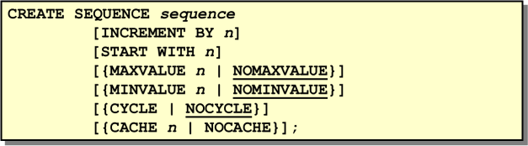

### Creating a Sequence

Automatically generate sequential numbers by using the CREATE SEQUENCE statement. In the syntax:

***sequence*** is the name of the sequence generator

***INCREMENT BY n*** specifies the interval between sequence numbers where *n* is an integer (If this clause is omitted, the sequence will increment by 1.)

***START WITH n*** specifies the first sequence number to be generated (If this clause is omitted, the sequence will start with 1.)

***MAXVALUE n*** specifies the maximum value the sequence can generate

***NOMAXVALUE*** specifies a maximum value of 10^27 for an ascending sequence and –1 for a descending sequence (This is the default option.)

***MINVALUE n*** specifies the minimum sequence value

***NOMINVALUE*** specifies a minimum value of 1 for an ascending sequence and – (10^26) for a descending sequence (This is the default option.)

***CYCLE | NOCYCLE*** specifies that the sequence continues to generate values after reaching either its maximum or minimum value or does not generate additional values (NOCYCLE is the default option.)

***CACHE n | NOCACHE*** specifies how many values the Oracle Server will pre allocate and keep in memory (By default, the Oracle Server will cache 20 values.)

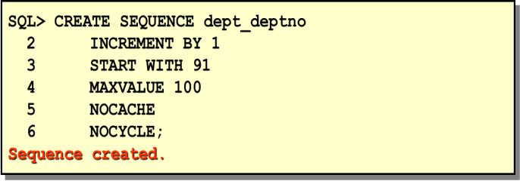

The above example creates a sequence named DEPT_DEPTNO to be used for the DEPTNO column of the DEPT table. The sequence starts at 91, does not allow caching, and does not allow the sequence to cycle. Do not use the CYCLE option if the sequence is used to generate primary key values unless you have a reliable mechanism that purges old rows faster than the sequence cycles.

### Confirming Sequences

Once you have created your sequence, it is documented in the data dictionary. Since a sequence is a database object, you can identify it in the USER_OBJECTS data dictionary table. You can also confirm the settings of the sequence by selecting from the data dictionary USER_SEQUENCES table.

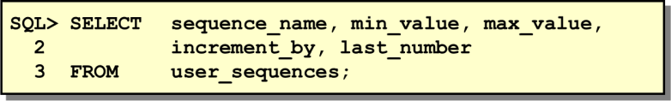

### Using a Sequence

Once you create your sequence, you can use the sequence to generate sequential numbers for use in your tables. Reference the sequence values by using the NEXTVAL and CURRVAL pseudocolumns.

### NEXTVAL and CURRVAL Pseudocolumns

The NEXTVAL pseudocolumn is used to extract successive sequence numbers from a specified sequence. You must qualify NEXTVAL with the sequence name. When you reference *sequence*.NEXTVAL, a new sequence number is generated and the current sequence number is placed in CURRVAL. The CURRVAL pseudocolumn is used to refer to a sequence number that the current user has just generated. NEXTVAL must be used to generate a sequence number in the current user’s session before CURRVAL can be referenced. You must qualify CURRVAL with the sequence name. When *sequence*.CURRVAL is referenced, the last value returned to that user’s process is displayed.

### Rules for Using NEXTVAL and CURRVAL

You can use NEXTVAL and CURRVAL in the following:

* + The SELECT list of a SELECT statement that is not part of a subquery
  + The SELECT list of a subquery in an INSERT statement
  + The VALUES clause of an INSERT statement
  + The SET clause of an UPDATE statement

You cannot use NEXTVAL and CURRVAL in the following:

* + A SELECT list of a view
  + A SELECT statement with the DISTINCT keyword
  + A SELECT statement with the GROUP BY, HAVING, or ORDER BY clauses
  + A subquery in a SELECT, DELETE, or UPDATE statement
  + A DEFAULT expression in a CREATE TABLE or ALTER TABLE statement

### Using a Sequence

The example inserts a new department in the DEPT table. It uses the DEPT_DEPTNO sequence for generating a new department number.

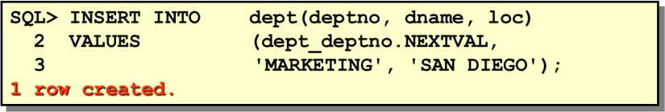

You can view the current value of the sequence:

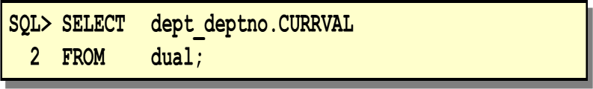

### Caching Sequence Values

Cache sequences in the memory to allow faster access to those sequence values. The cache is populated at the first reference to the sequence. Each request for the next sequence value is retrieved from the cached sequence. After the last sequence is used, the next request for the sequence pulls another cache of sequences into memory.

### Beware of Gaps in Your Sequence

Although sequence generators issue sequential numbers without gaps, this action occurs independent of a commit or rollback. Therefore, if you roll back a statement containing a sequence, the number is lost. Another event that can cause gaps in the sequence is a system crash. If the sequence caches values in the memory, then those values are lost if the system crashes. Because sequences are not tied directly to tables, the same sequence can be used for multiple tables. If this occurs, each table can contain gaps in the sequential numbers.

### Viewing the Next Available Sequence Value without Incrementing It

If the sequence was created with NOCACHE, it is possible to view the next available sequence value without incrementing it by querying the USER_SEQUENCES table.

### Altering a Sequence

If you reach the MAXVALUE limit for your sequence, no additional values from the sequence will be allocated and you will receive an error indicating that the sequence exceeds the MAXVALUE. To continue to use the sequence, you can modify it by using the ALTER SEQUENCE statement.

### Syntax

ALTER SEQUENCE ***sequence***

[INCREMENT BY *n*]

[{MAXVALUE *n* | NOMAXVALUE}] [{MINVALUE *n* | NOMINVALUE}] [{CYCLE | NOCYCLE}]

[{CACHE *n* | NOCACHE}];

**Where: *sequence*** is the name of the sequence generator

### Guidelines

* You must be the owner have the ALTER privilege for the sequence in order to modify it.
* Only future sequence numbers are affected by the ALTER SEQUENCE statement.
* The START WITH option cannot be changed using ALTER SEQUENCE. The sequence must be dropped and re-created in order to restart the sequence at a different number.
* Some validation is performed. For example, a new MAXVALUE cannot be imposed that is less than the current sequence number.

### Removing a Sequence

To remove a sequence from the data dictionary, use the DROP SEQUENCE statement. You must be the owner of the sequence or have the DROP ANY SEQUENCE privilege to remove it.

### Syntax

DROP SEQUENCE ***sequence***;

**Where: *sequence*** is the name of the sequence generator

***Exercise:***

1. Create a sequence to be used with the primary key column of the DEPARTMENT table. The sequence should start at 60 and have a maximum value of 200. Have your sequence increment by ten numbers. Name the sequence DEPT_ID_SEQ.
2. Write a script to display the following information about your sequences: sequence name, maximum value, increment size, and last number.
3. Write an interactive script to insert a row into the DEPARTMENT table. Be sure to use the sequence that you created for the ID column. Create a customized prompt to enter the department name. Execute your script. Add two departments named Education and Administration. Confirm your additions.

# Lecture-21 (User Control Access)

#### Objective:

* + Create users
  + Create roles to ease setup and maintenance of the security model
  + Use the GRANT and REVOKE statements to grant and revoke object privileges
  + Create and access database links

#### User Privileges

* + Database security:
    - System security
    - Data security
  + System privileges: Gaining access to the database
  + Object privileges: Manipulating the content of the database objects
  + Schemas: Collections of objects, such as tables, views, and sequences

#### System Privileges

* + More than 100 privileges are available.
  + The database administrator has high-level system privileges for tasks such as:
    - Creating new users
    - Removing users
    - Removing tables
    - Backing up tables

#### Creating Users

The DBA creates users by using the CREATE USER statement. General form: *CREATE USER userIDENTIFIED BY password;* Example:*CREATE USER scottIDENTIFIED BY tiger;*

#### User System Privileges

* Once a user is created, the DBA can grant specific system privileges to a user.

GRANT *privilege* [, *privilege*...] TO *user* [, *user| role, PUBLIC*...];

* An application developer, for example, may have the following system privileges:
* CREATE SESSION
* CREATE TABLE
* CREATE SEQUENCE
* CREATE VIEW
* CREATE PROCEDURE

#### Granting System Privileges

The DBA can grant a user specific system privileges.

*GRANT create session, create table, create sequence, create view TO scott;*

#### Creating and granting privillages to ROLE

*CREATE ROLE manager;*

*GRANT create table, create view TO manager; GRANT manager TO DEHAAN, KOCHHAR;*

#### Changing Your Password

* The DBA creates your user account and initializes your password.
* You can change your password by using the ALTER USER statement.

*ALTER USER scott IDENTIFIED BY lion;*

**Object Privileges**

|  |  |  |  |  |
| --- | --- | --- | --- | --- |
| **Object Privilege** | *Table* | *View* | *Sequence* | *Procedure* |
| **Alter** |  |  |  |  |
| **Delete** |  |  |  |  |
| **Execute** |  |  |  |  |
| **Index** |  |  |  |  |
| **Insert** |  |  |  |  |
| **References** |  |  |  |  |
| **Select** |  |  |  |  |
| **Update** |  |  |  |  |

* Object privileges vary from object to object.
* An owner has all the privileges on the object.
* An owner can give specific privileges on that owner’s object.

*GRANT object_priv[(columns)]ONobjectTO {user|role|PUBLIC} [WITH GRANT OPTION];*

### Granting Object Privileges

* Grant query privileges on the EMPLOYEES table.
* Grant privileges to update specific columns to users and roles.

*GRANT select ON employees TO sue, rich;*

*GRANT update (department_name, location_id) ON departments TO scott, manager;*

### Using the WITH GRANT OPTION and PUBLIC Keywords

* Give a user authority to pass along privileges.
* Allow all users on the system to query data from Alice’s DEPARTMENTS table.

*GRANT select, insert ON departments TO scottWITH GRANT OPTION; GRANT select ON alice.departmentsTO PUBLIC;*

### Confirming Privilege Granted

|  |  |
| --- | --- |
| **Data Dictionary View** | **Description** |
| ROLE_SYS_PRIVS | System privileges granted to roles |
| ROLE_TAB_PRIVS | Table privileges granted to roles |
| USER_ROLE_PRIVS | Roles accessible by the user |
| USER_TAB_PRIVS_MADE | Object privileges granted on the  user’s objects |
| USER_TAB_PRIVS_RECD | Object privileges granted to the  User |
| USER_COL_PRIVS_MADE | Object privileges granted on the  columns of the user’s objects |
| USER_COL_PRIVS_RECD | Object privileges granted to the  user on specific columns |
| USER_SYS_PRIVS | Lists system privileges granted to  the user |

**How to Revoke Object Privileges**

* You use the REVOKE statement to revoke privileges granted to other users.
* Privileges granted to others through the WITH GRANT OPTION clause are also revoked.

*REVOKE {privilege [, privilege...]|ALL} ON object FROM {user[, user...] |role|PUBLIC} [CASCADE CONSTRAINTS];*

As user Alice, revoke the SELECT and INSERT privileges given to user Scott on the DEPARTMENTS table.

*REVOKE select, insert ON departments FROM scott;*

#### Exercise:

Suppose you are the DBA for the following schemas. Complete the following task with appropriate sql command.

### Employee Departments

|  |  |  |  |  |  |  |  |  |  |
| --- | --- | --- | --- | --- | --- | --- | --- | --- | --- |
|  | Eid | | EName | | Job | | Supervisor | Sal | Did |
| E001 | | Asif | | Manager | | E009 | 20000.00 | 10 |
| E002 | | Arif | | Manager | | E009 | 30000.00 | 10 |
| E004 | | Abul | | Salesman | | E001 | 15000.00 | 20 |
| E005 | | Kuddus | | Salesman | | E001 | 15000.00 | 20 |
| E006 | | Maruf | | Salesman | | E003 | 15000.00 | 20 |
| E009 | | Hasan | | President | |  | 40000.00 | 10 |
| Did | | Name | | Manager | |  | | | |
| 10 | | Admin | | E009 | |
| 20 | | Sales | | E002 | |

**Products OrderDetais**

|  |  |  |
| --- | --- | --- |
| ProductID | PName | Price |
| P001 | Machinery | 50000.00 |
| P002 | Hardware | 55000.00 |
| P003 | Software | 65000.00 |

|  |  |  |
| --- | --- | --- |
| OrderID | ProductID | Quantity |
| O001 | P001 | 10 |
| O002 | P001 | 10 |
| O002 | P003 | 10 |
| O003 | P002 | 10 |

1. Create a user **Rahul** with the password

### ret23erz.

1. Create a new role **Accounts**.
2. Grant system privileges create table, view and sequence to role Accounts.
3. Assign role Accounts to Rahul.
4. Change password of **Rahul** with the new password **rec34tg**
5. Grant query privilege to Asif and Arif on Departments table.
6. Grant privilege update to column Price on OrderDetails table to role Manager and user Hasan.
7. Give Asif the authority to pass along update and insert privilege on Departments table.
8. Revoke the update and delete privileges given to user kuddus on Product table.

# Last Week Lecture -(Project Presentation and Discussion)